**FlyAway (An Airline Booking Portal)**

**Code:**

**Start.jsp**

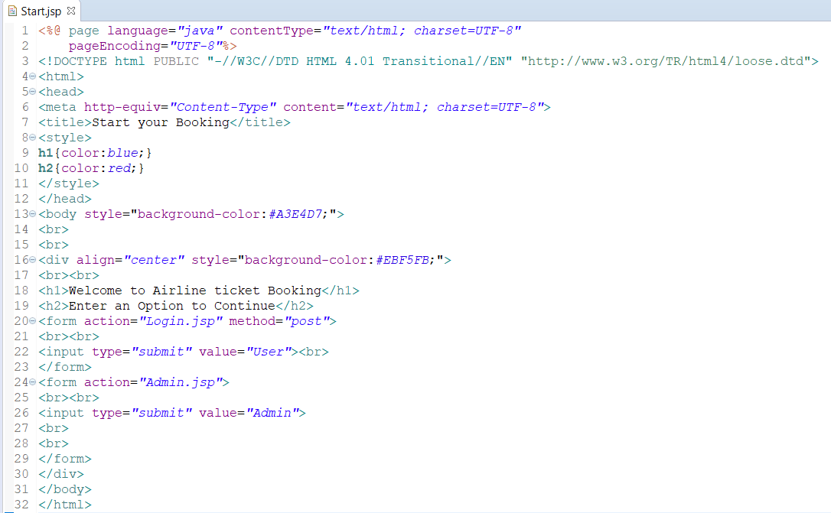

**Login.jsp**

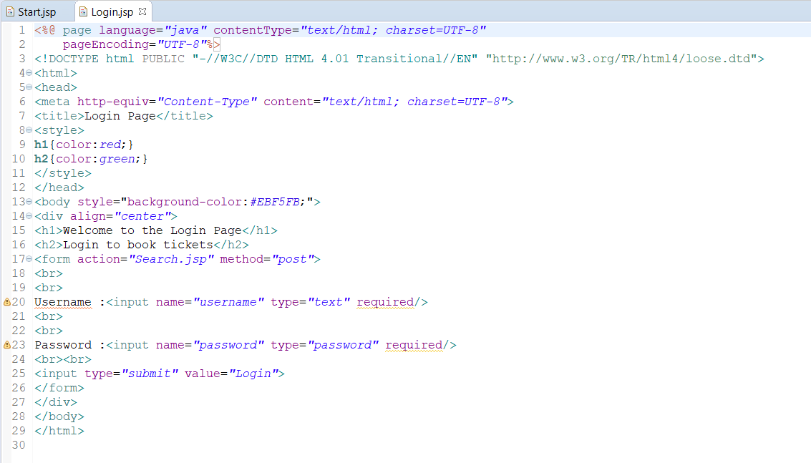

**Search.jsp**

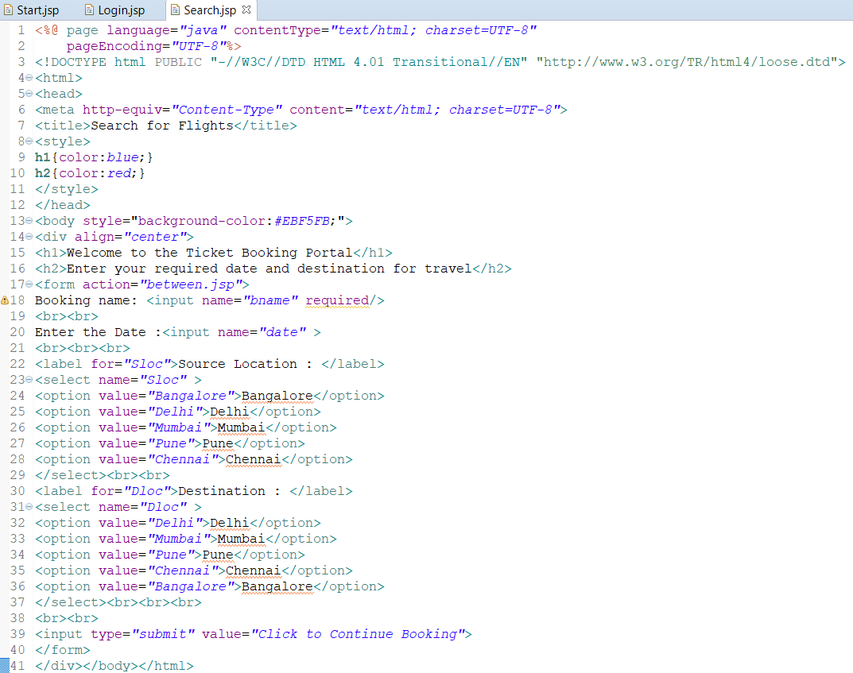

**between.jsp**

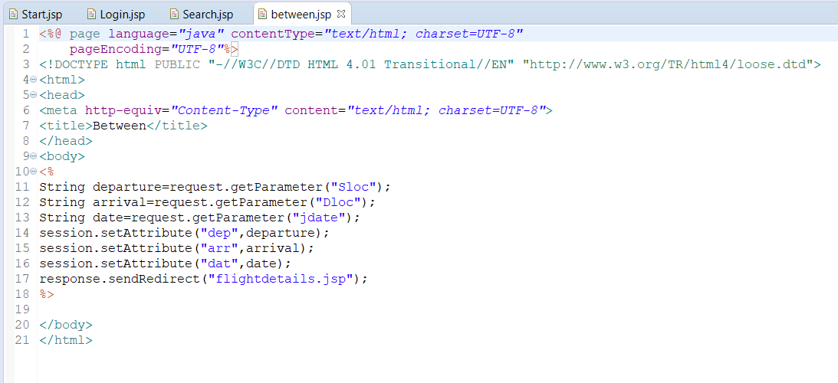

**flightdetails.jsp**

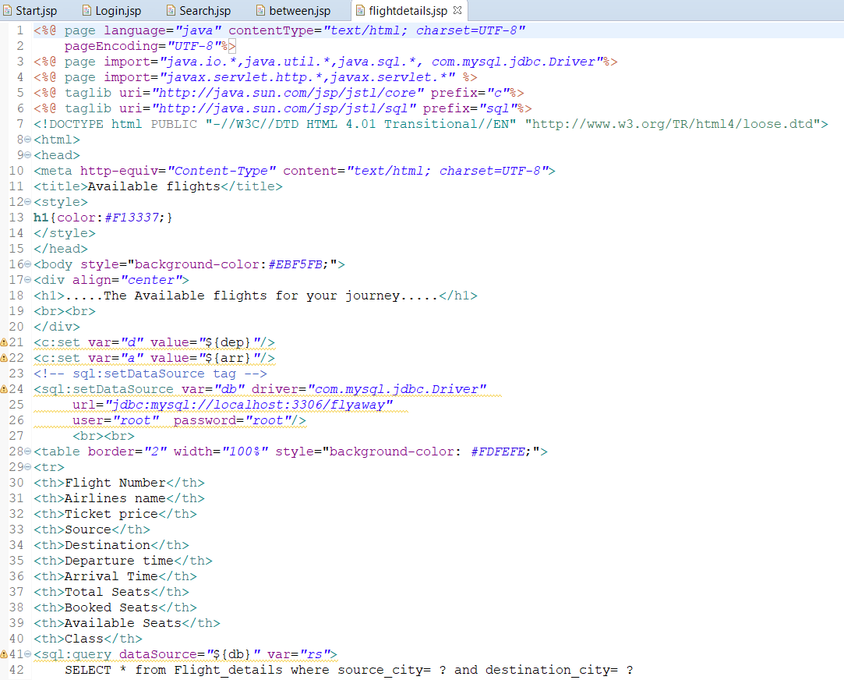

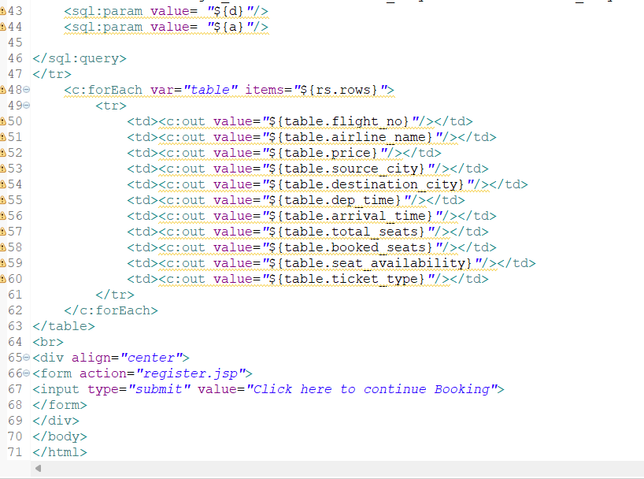

**register.jsp**

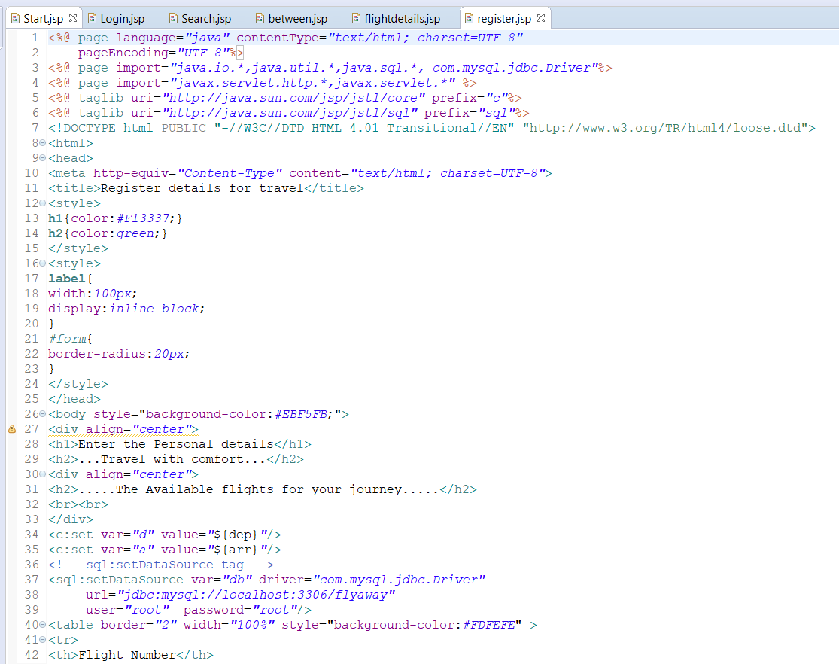

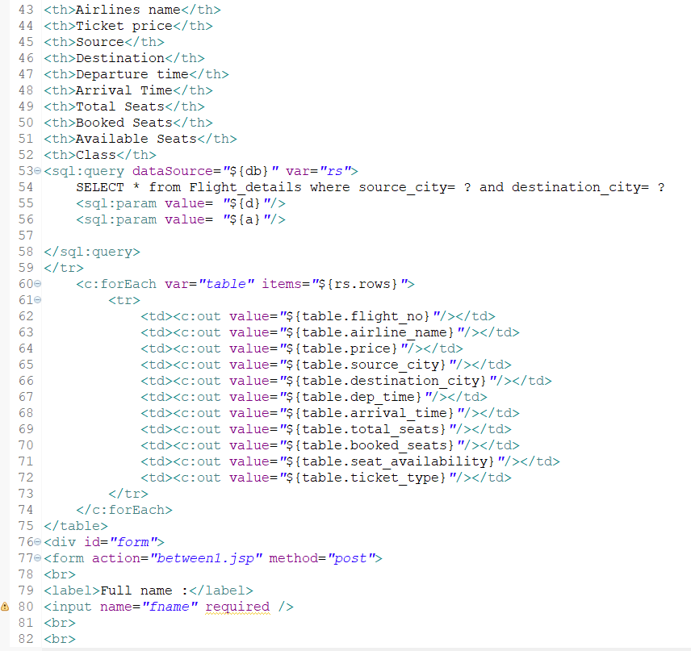

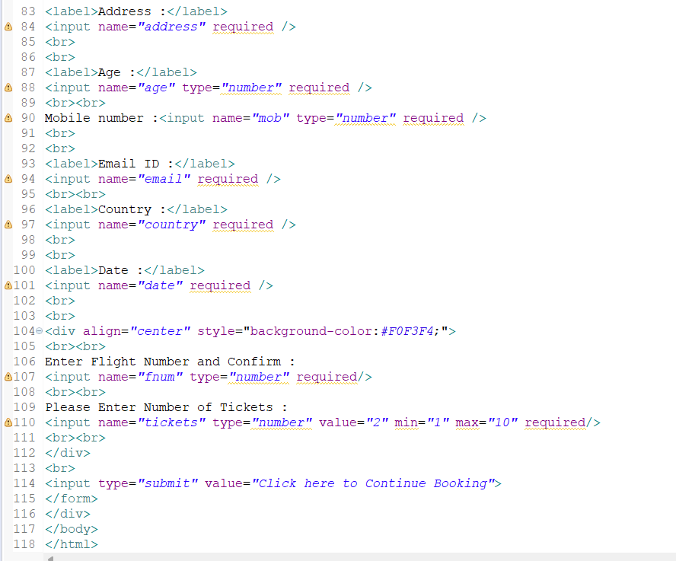

**between1.jsp**

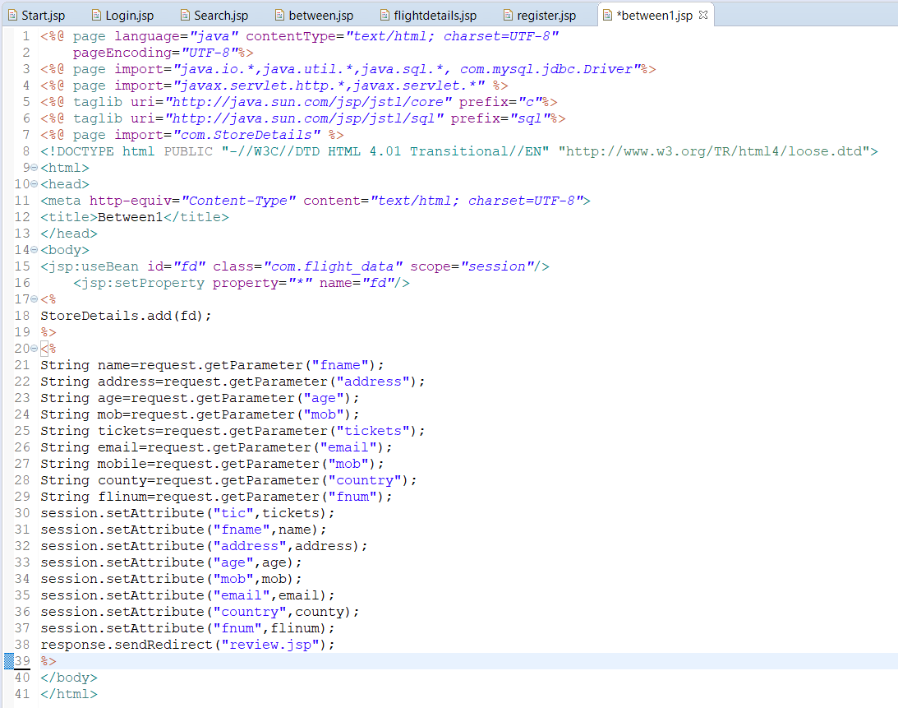

**review.jsp**

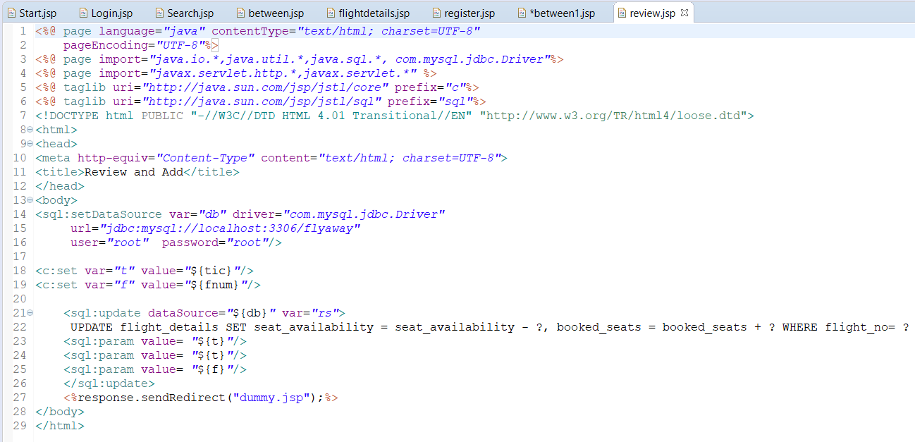

**dummy.jsp**

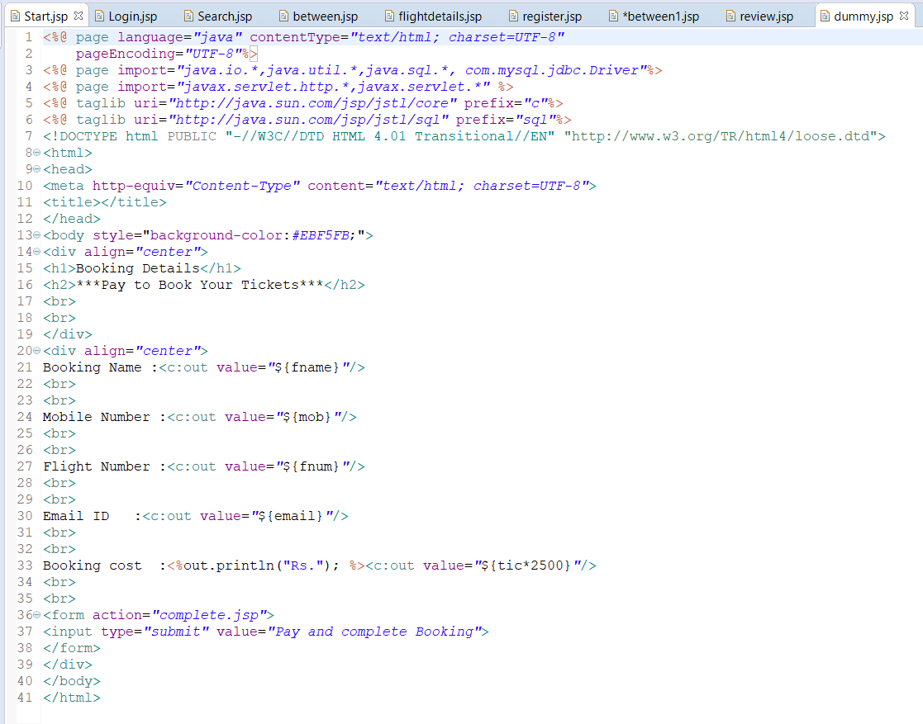

**complete.jsp**

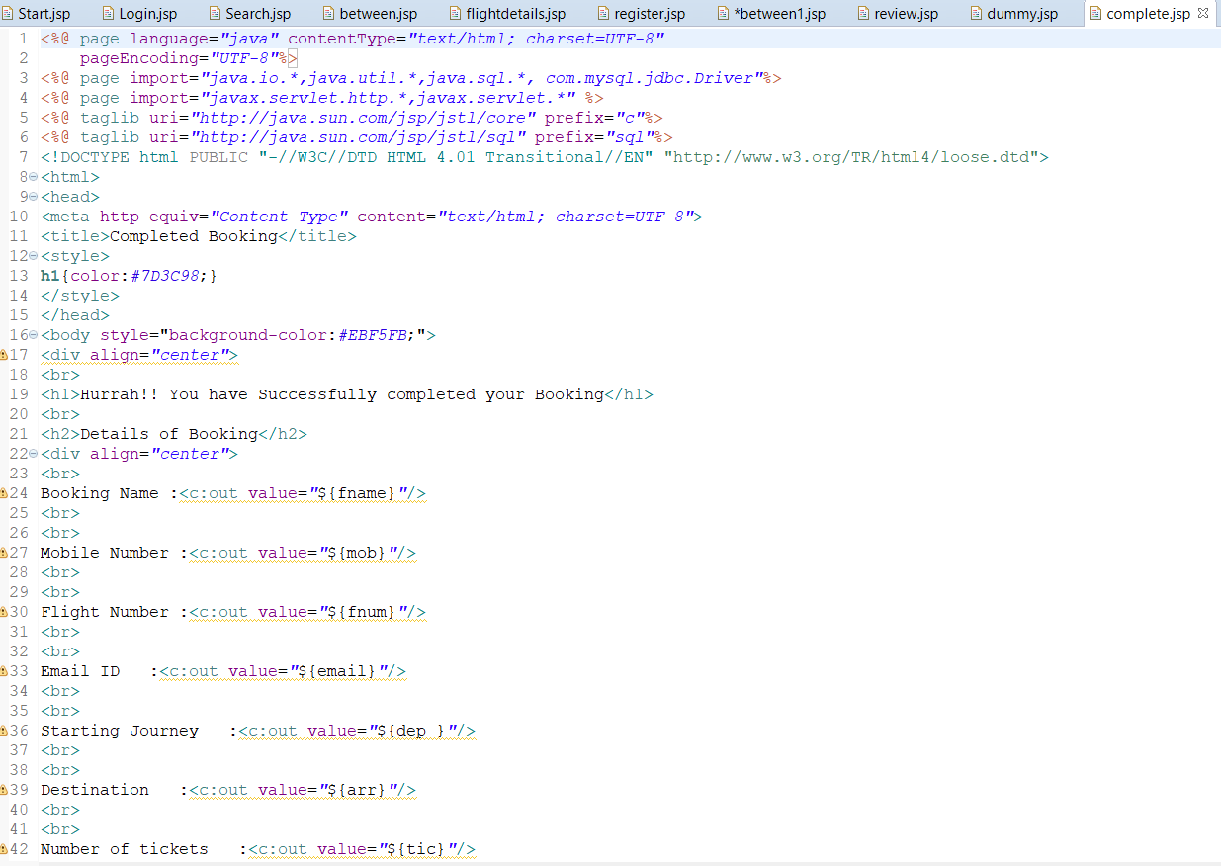

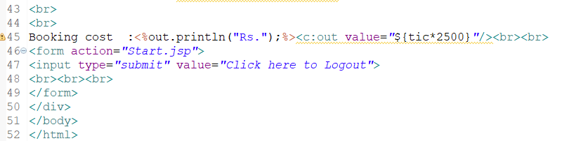

**Admin.jsp**

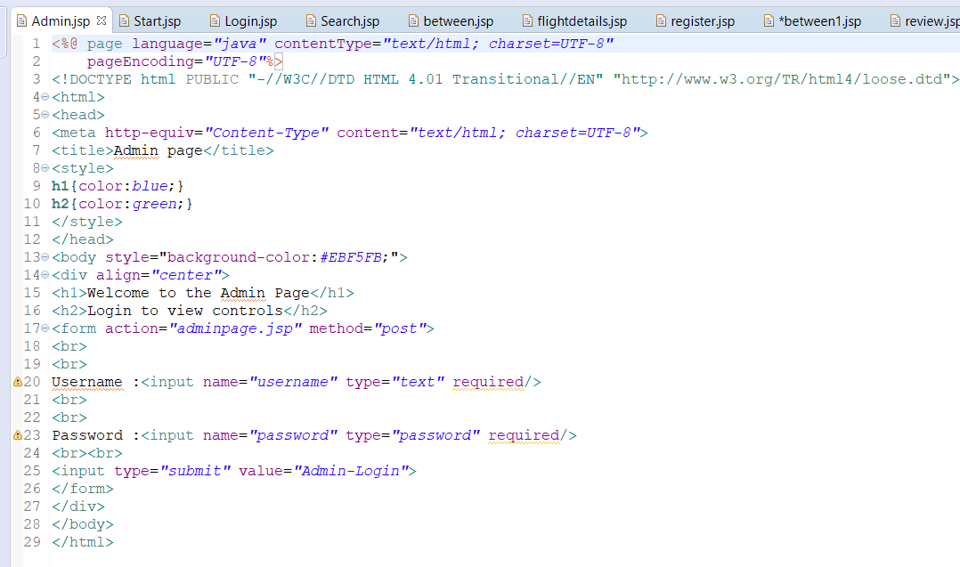

**adminpage.jsp**

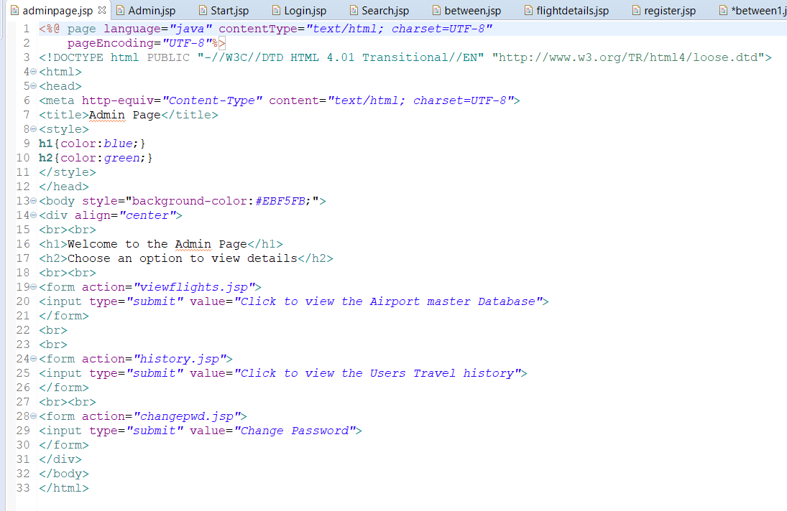

**Output:**

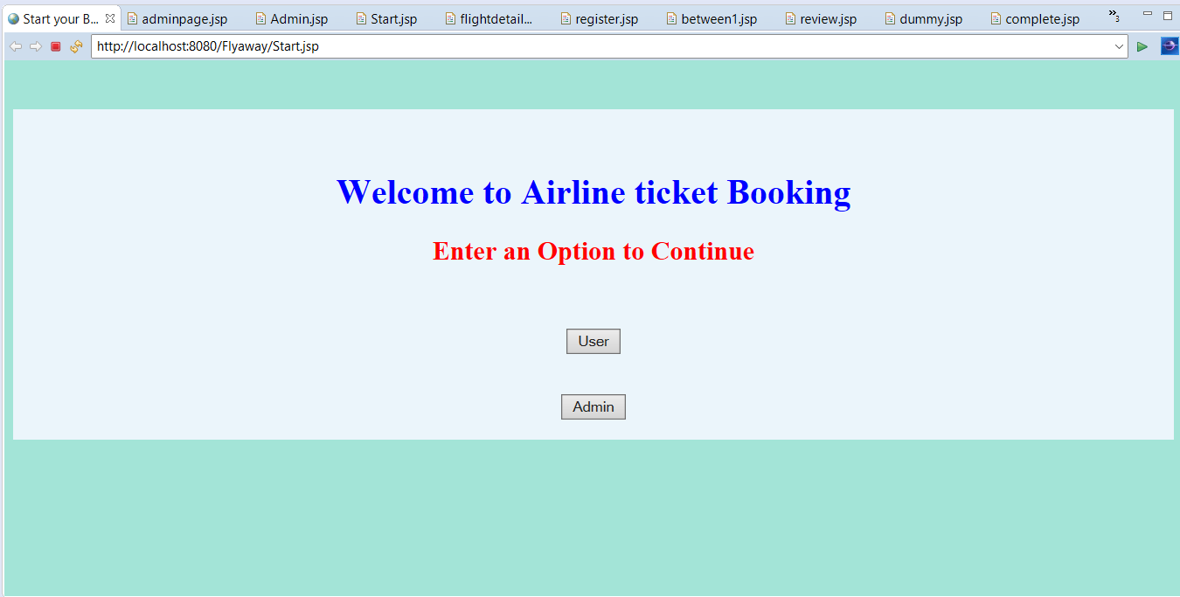

**When logged in as User**

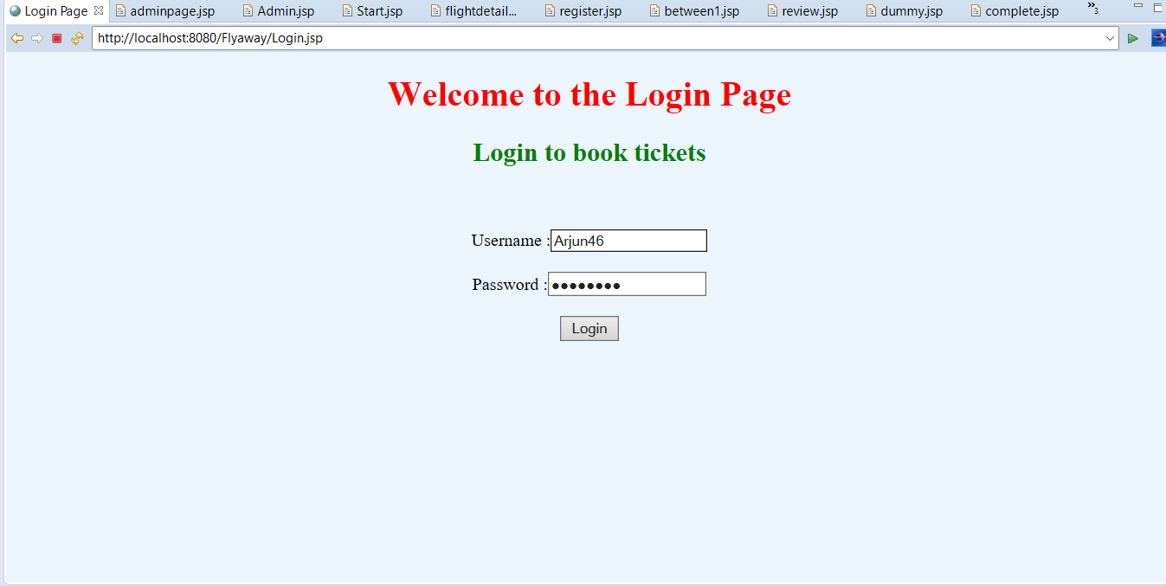

**Enter asked details:**

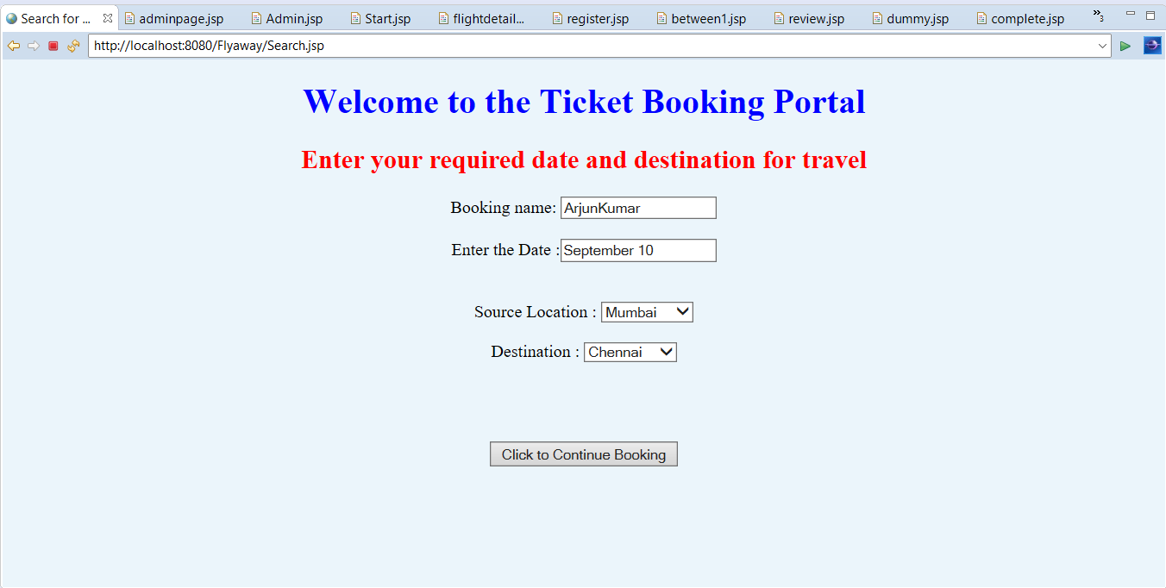

**It will show available flights for entered details**

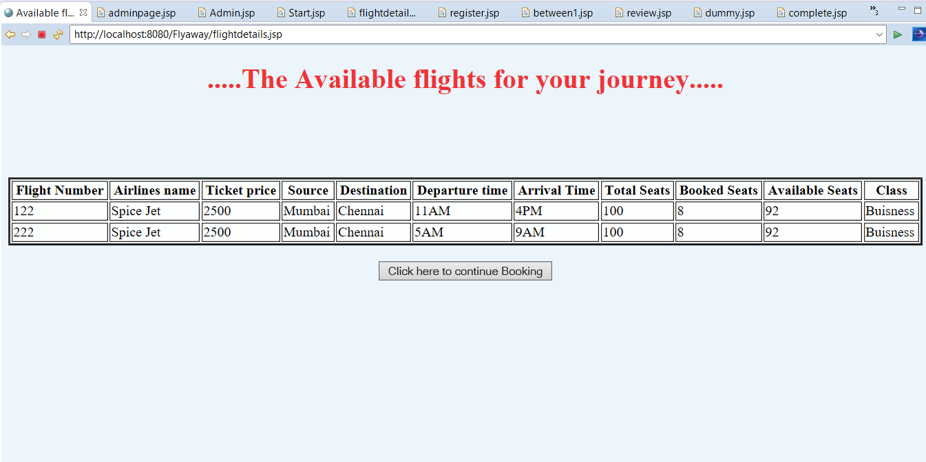

**Next page**

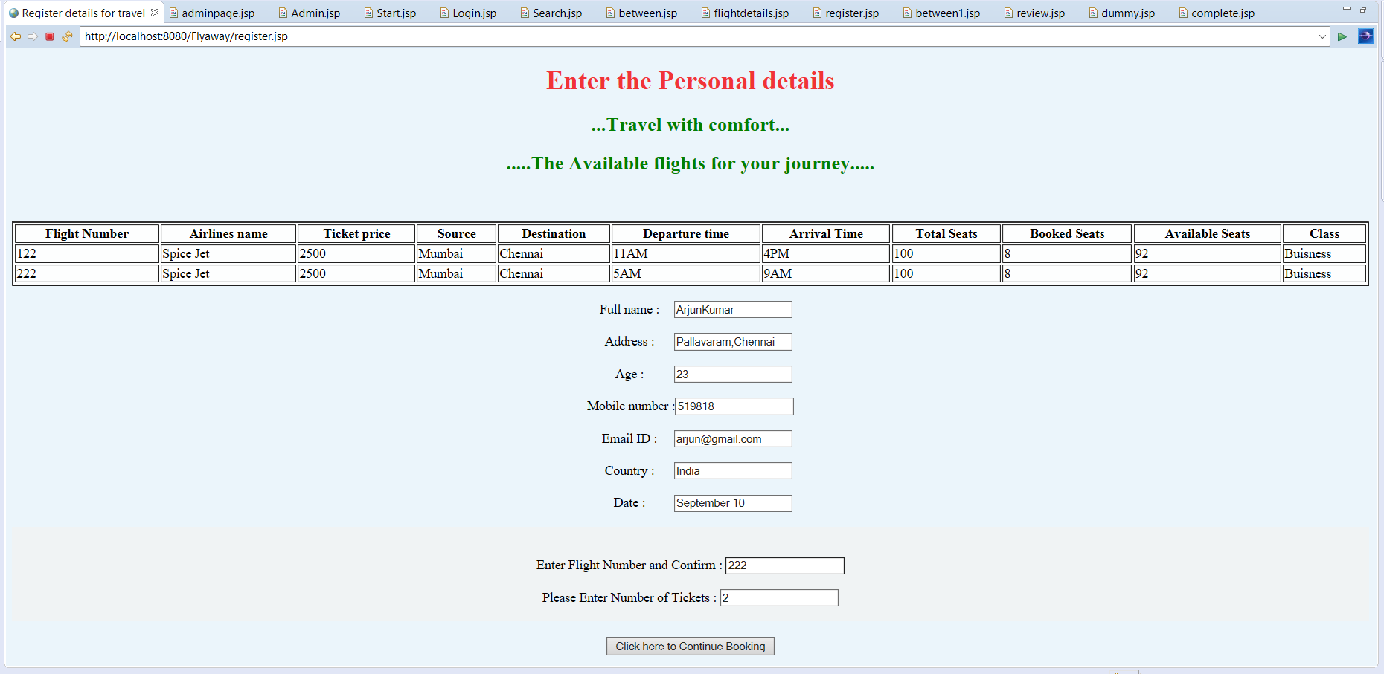

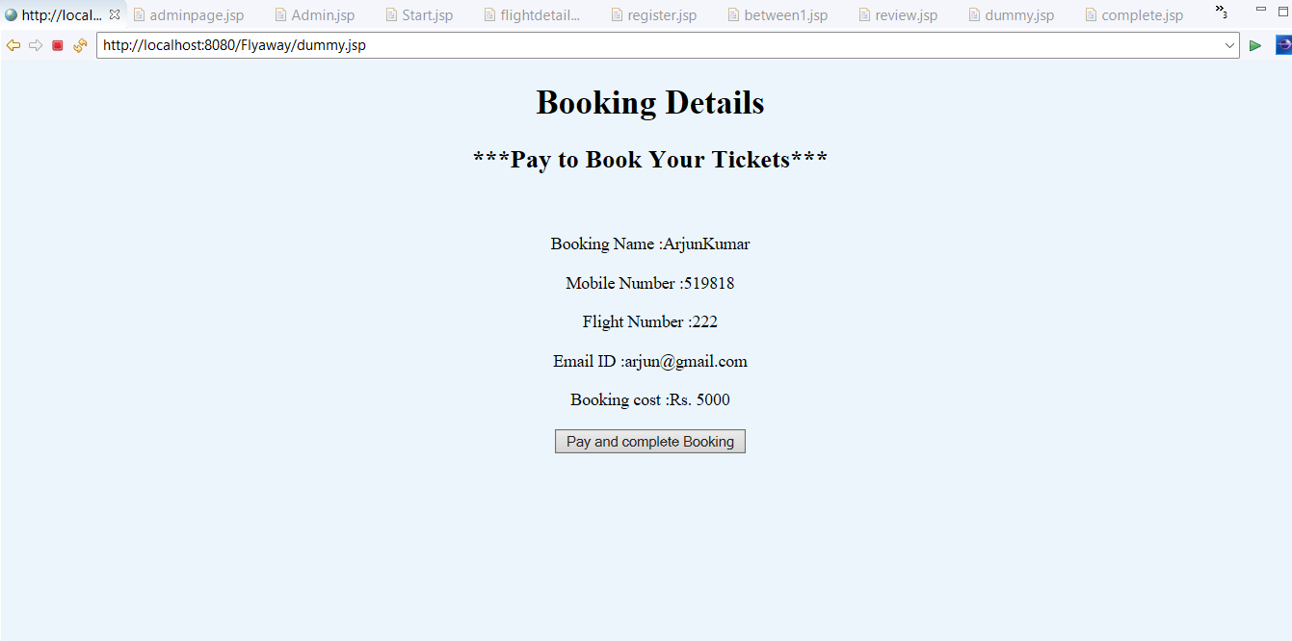

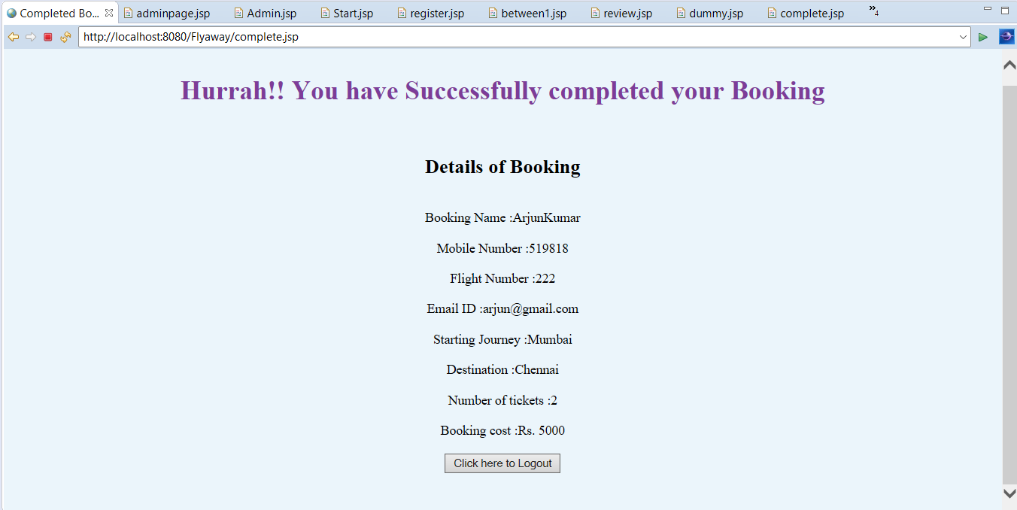

**Admin has the Options to view details of all the flights and also can see user booking history from the respective databases**

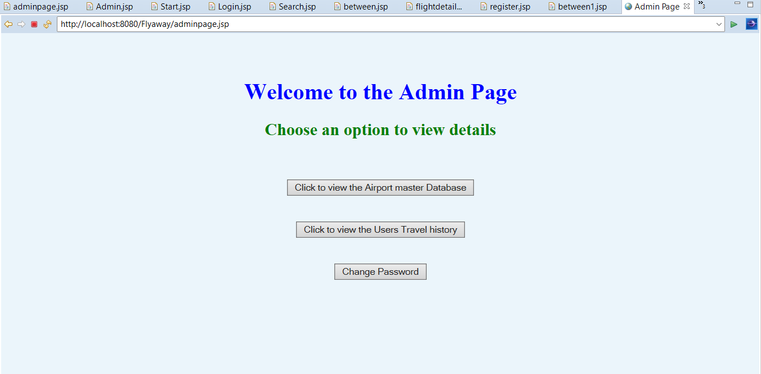

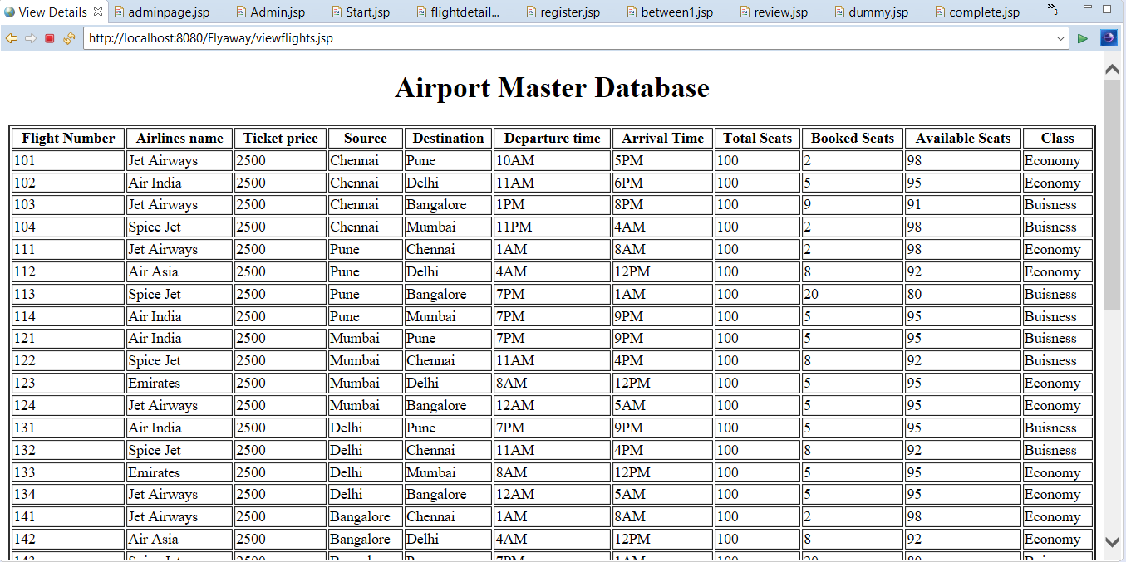

**User booking history is stored when we book a ticket**

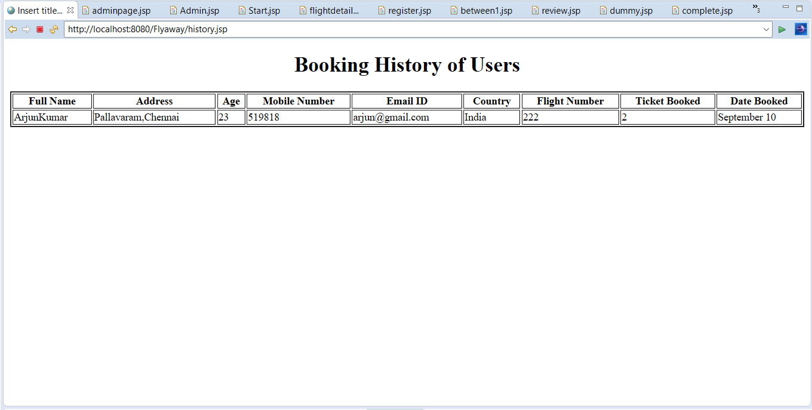

**The seat availability and booked seats data is updated to the database after each booking by the user using the SQL Update query.**

**The user history database before another booking**

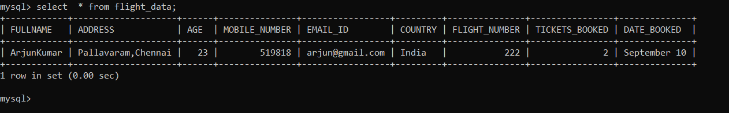

**The available seats in flight no:101 before booking**

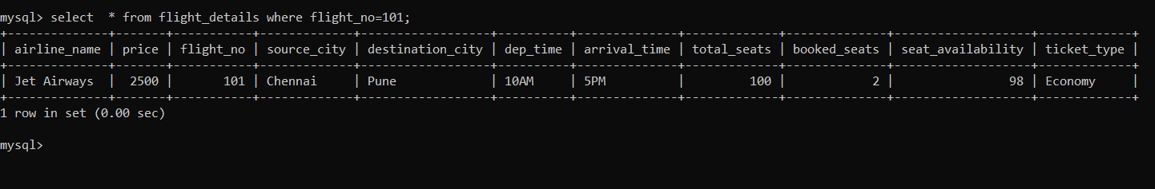

**Booking 10 tickets and then database is updated**

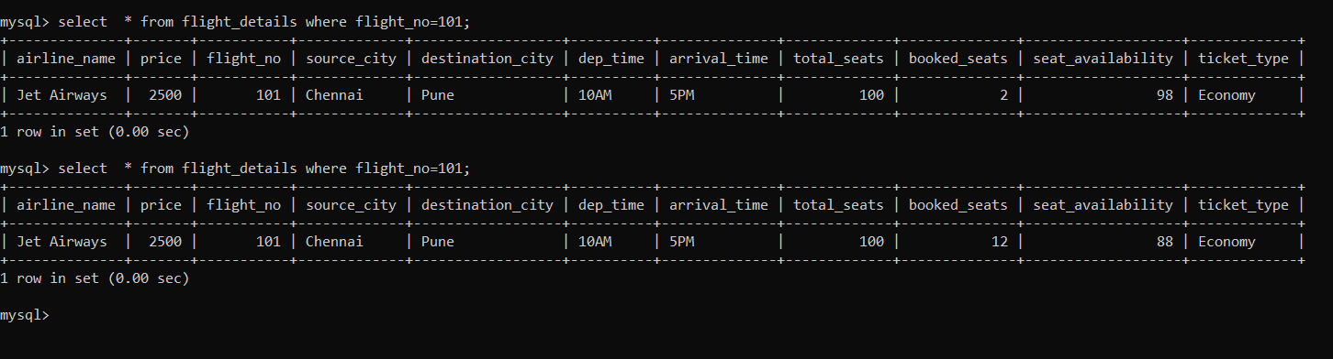

**The database is updated after booking 10 tickets.**

**Booking history page in Admin view autoupdated**

